**CHANDIGARH UNIVERSITY**

UNIVERSITY INSTITUTE OF ENGINEERING

**DEPARTMENT OF COMPUTER SCIENCE & ENGINEERING**



|  |  |
| --- | --- |
| **Submitted By:                                                                          Submitted To:**  Yash Gupta Monika(E12802) | |
| **Subject Name** | Design Analysis and Algorithm |
| **Subject Code** | 20CSP_312 |
| **Branch** | CSE |
| **Semester** | 5th |

**LAB -INDEX**

|  |  |  |  |  |  |  |  |
| --- | --- | --- | --- | --- | --- | --- | --- |
| **Sr.No** | **Program** | **Date** | **Evaluation** | | | | **Sign** |
| **LW(12)** | **VV(8)** | **FW(10)** | **Total (30)** |
|  |  |  |  |  |  |  |  |
|  |  |  |  |  |  |  |  |
|  |  |  |  |  |  |  |  |
|  |  |  |  |  |  |  |  |
|  |  |  |  |  |  |  |  |
|  |  |  |  |  |  |  |  |
|  |  |  |  |  |  |  |  |
|  |  |  |  |  |  |  |  |
|  |  |  |  |  |  |  |  |
|  |  |  |  |  |  |  |  |

**Experiment 2**

**1. Aim/Overview of the practical:**

***Code implement power function in O(log n) time complexity***

**2. Algorithm:**

**Step1:** Take x and n input.

**Step2:** Calculate pow(x, n) method check base condition if n==0 return 1 check base condition if n==1 return x recursively callpow(x,n-1) and go to step 2;

**Step 3:** Print result.

**3. Steps for experiment/practical/Code:**

#include<iostream>

using namespace std;

class calculate{

public:

int power(int x, int y)

{int temp;

if( y == 0)

return 1;

temp = power(x, y/2);

if (y%2 == 0)

return temp*temp;

else

return x*temp*temp; }};

int main()

{calculate g;

int x = 2;

int y = 3;

cout << g.power(x, y);

return 0;}

**4. Result/Output/Writing Summary:**

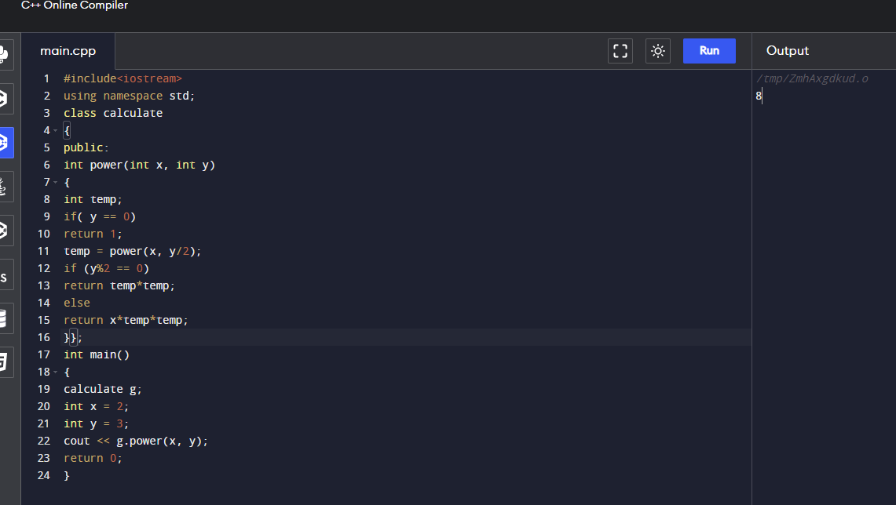

**5. Observations/Discussions/ Complexity Analysis:**

Time complexity of finding power of a number using recursion is O(log n).

**6. Learning outcomes (What I have learnt):**

**1.** To know to calculate power of a function.

**2.** To learn how to use recursion for solving problems.

**Evaluation Grid (To be created as per the SOP and Assessment guidelines by the faculty):**

|  |  |  |  |
| --- | --- | --- | --- |
| Sr. No. | Parameters | Marks Obtained | Maximum Marks |
| 1. |  |  |  |
| 2. |  |  |  |
| 3. |  |  |  |
|  |  |  |  |